FORNAX™ ePlanCheck Rule
Rule Information
Rule ID | SSW 3.1.2 (m)
Rule Name | Drain-line Pipe Material and Connection to Sewer Line
Chapter | 3. Sanitary Works
Section | 3.1 Sanitary Drainage System
Handbook | Code of Practice on Sewerage and Sanitary Works  Addendum No. 2 – Nov 2004

Rule Description
3.1.2 Design Criteria

(m) No uPVC pipe shall be used for sewer connection. The connecting drain-line from last inspection chamber to
an existing/new manhole shall not be smaller than 200mm in diameter. This is regardless of the size of the
existing sewer.

Rule Interpretation
- This rule checks for the material and minimum diameter of the pipe used in connection between the last inspection chamber and sewer manhole. This connection is referred to as the Sewer Connection line.
- The material of the Sewer Connection line pipe cannot be uPVC.
- The minimum diameter of the Sewer Connection is 200 mm.
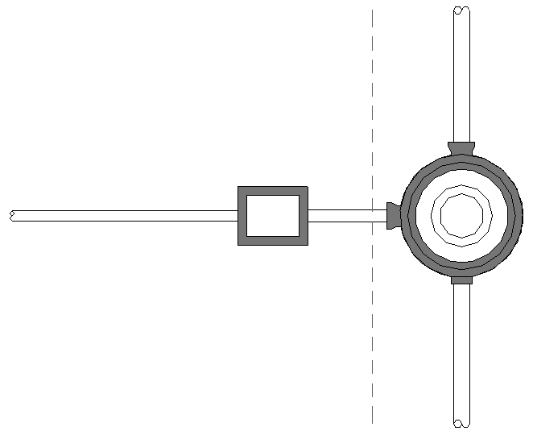
PUBLIC CSEWER LINE

(LAST) INSPECTION CHAMBER

MAIN DRAIN LINE
MANHOLE LINE

PROPERTY LINE
MINIMUM 200MM DIAMETER NON-PVC SEWER CONNECTION LINE PIPE
PUBLIC SEWER LINE

PLAN
FIGURE 01

Rule Scenario

Scenario 01-Compliant
Requirement | - Sewer Connection pipe should not be of uPVC material.  - Minimum diameter of the Sewer Connection pipe should not be smaller than 200m.
Conditions | Irrespective of the size of the public sewer line pipe.
Description | Sewer Connection pipe diameter = 200mm from the last Inspection Chamber to sewer manhole with a 250mm diameter public sewer line. Connecting pipe material is Cast Iron pipe.
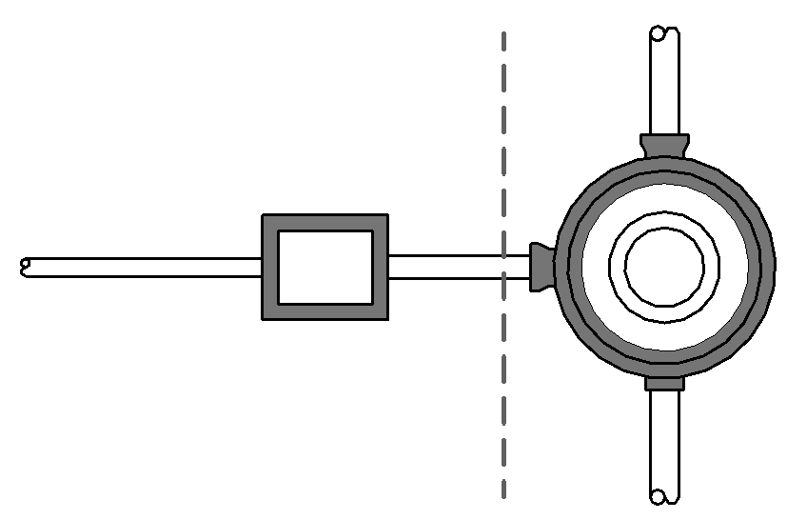
PUBLIC SEWER LINE

PROPERTY LINE
(LAST)
INSPECTION
CHAMBER

MAIN DRAIN-LINE
SEWER MANHOLEE

PUBLIC SEWER LINE
CAST IRON
SEWER CONNECTION
PIPE=200mmØ

PLAN
FIGURE SCENARIO

Scenario 01-Non-compliant 1
Requirement | - Sewer Connection pipe should not be of uPVC material.  - Minimum diameter of the Sewer Connection pipe should not be smaller than 200m.
Conditions | Irrespective of the size of the public sewer line pipe.
Description | Sewer Connection pipe diameter = 200mm from the last Inspection Chamber to sewer manhole with a 250mm diameter public sewer line. Connecting pipe material is uPVC pipe.
PUBLIC
SEWER LINE
PROPERTY LINE

(LAST)
INSPECTION
CHAMBER

MAIN DRAIN-LINE
SEWER MANHOLE

PUBLIC
SEWER LINE
uPVC
SEWER CONNECTION PIPE=200mmØ

PLAN
FIGURE SCENARIO

Scenario 01-Non-compliant 2
Requirement | - Sewer Connection pipe should not be of uPVC material.  - Minimum diameter of the Sewer Connection pipe should not be smaller than 200m.
Conditions | Irrespective of the size of the public sewer line pipe.
Description | Sewer Connection pipe diameter = 150mm from the last Inspection Chamber to sewer manhole with a 250mm diameter public sewer line. Connecting pipe material is Cast Iron pipe.  PUBLIC  SEWER LINE
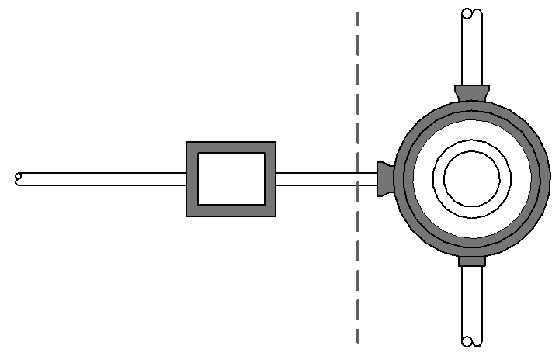
PROPERTY LINE

(LAST)
INSPECTION
CHAMBER

MAIN DRAIN-LINE
SEWER MANHOLE

CAST IRON
SEWER CONNECTION PIPE=150mmØ
PUBLIC
SEWER LINE

PLAN

FIGURE SCENARIO

Model PreCheck

Required Elements | Required Attributes
PipeSegment | IfcDescription contains “Sewer Connection”
DistributionChamberElement | IfcName contains “Sewer Manhole”
DistributionChamberElement | IfcName contains “Inspection Chamber”

Rule Parameters

System Type
Cold Water
Hot Water
 | Sanitary
 | Sewerage | 
Vent

Element Type 1
State | Type | Property | Operator | Value
Include | PipeSegment | IfcDescription | Contains | Sewer Connection
Exclude |  | Any | Match | N.A.
 |  |  | N.A. | <User defined>

Element Type 2
State | Type | Property | Operator | Value
Include | DistributionChamberElement | Name | Contains | Manhole
Exclude |  | Any | Match | N.A.
 |  |  | N.A. | <User defined>

Element Type 3
State | Type | Property | Operator | Value
Include | DistributionChamberElement | Name | Contains | Inspection Chamber
Exclude |  | Any | Match | N.A.
 |  | Name | N.A. | <User defined>

Element Type 1 Condition
Minimum diameter = | 200 | mm
* Should not have material containing “PVC”
* Should be connected to Elements Type 2 & 3

Result Messages
- 3.1.2 (m) Merging of Sewer Connection Pipe to Sewer Line
- Non-compliant (TotalResultNumeric)
- BuildingStorey (TotalResultPerFloorNumeric)
  - ElementNameNumeric: Diameter = ResultValueNumeric mm; ResultMaterialValue Pipe
- Compliant (TotalResultNumeric)
- BuildingStorey (TotalResultPerFloorNumeric)
  - ElementNameNumeric: Diameter = ResultValueNumeric mm; ResultMaterialValue Pipe
- Attention (TotalResultNumeric)
    - BuildingStorey (TotalResultPerFloorNumeric)
      - No inspection chamber/manhole connected.

Sample Result Messages
- 3.1.2 (m) Merging of Sewer Connection Pipe to Sewer Line
- Non-compliant (2)
- Level 1 (1)
  - Sewer Connection Pipe 1.01: Diameter = 150 mm; Cast Iron Pipe
  - Sewer Connection Pipe 1.02: Diameter = 200 mm; uPVC Pipe
- Compliant (1)
- Level 1 (1)
  - Sewer Connection Pipe 1.03: Diameter = 200 mm; Cast Iron Pipe
- Attention (1)
- Level 1 (1)
  - No inspection chamber/manhole connected.

Sample Result Model Views
- 3.1.2 (m) Merging of Sewer Connection Pipe to Sewer Line
- Non-compliant
- Plan view.
- Highlight checked element/space.
- All other elements are translucent except checked element/space.
- Compliant
- Plan View.
- Highlight checked element/space.
- All other elements are translucent except checked element/space.

Testing Scenario Notes
- Scenario 01-Compliant
- Level 1
- Series of Inspection chamber is located within a lot with the last chamber near the boundary line.
The sewer connection pipe linking the last chamber to the sewer manhole has a diameter of
200mm with a material of Cast Iron.

- Scenario 01-Non-compliant 1
- Level 1
- Series of Inspection chamber is located within a lot with the last chamber near the boundary line.
The sewer connection pipe linking the last chamber to the sewer manhole has a diameter of
200mm but with a material of uPVC.

- Scenario 01-Non-compliant 2
- Level 1
- Series of Inspection chamber is located within a lot with the last chamber near the property line.
The sewer connection pipe linking the last chamber to the sewer manhole has a diameter of
150mm with a material of Cast Iron.

Model:
SSW 312m-01-C.ifc
SSW 312m-01-NC1.ifc
SSW 312m-01-NC2.ifc

Modelling Guideline
- Specify IfcDescription containing “Sewer Connection” for relevant PipeSegment.
- Specify IfcObjectType containing “uPVC” for relevant PipeSegment.
- Specify IfcDescription containing “Main Drain Line” for relevant PipeSegment.
- Specify IfcDescription containing “Public Sewer Line” for relevant PipeSegment.
- Specify IfcName and IfcExportAs containing “Inspection Chamber” for relevant DistributionChamberElement.
- Specify IfcName and IfcExportAs containing “Sewer Manhole” for relevant DistributionChamberElement

Specification Log
RA | Alvin Q. Estocapio
Last edit date | 27 June 2018
ePC version
Updates | - V1

Specification Log
RA | Alvin Q. Estocapio
Last edit date | 26 July 2018
ePC version
Updates | - V1-Update rule interpretation and scenarios.

Specification Log
RA | Alvin Q. Estocapio
Last edit date | 09 August 2018
ePC version
Updates | - V2- Update rule interpretation, Model Pre-check, Rule Parameters, Result Messages and Modelling Guidelines

Specification Log
RA | Alvin Q. Estocapio
Last edit date | 11 September 2018
ePC version
Updates | - V3- Update rule interpretation, Model Pre-check, Rule Parameters, Result Messages and Modelling Guidelines

Specification Log
RA | Alvin Q. Estocapio
Last edit date | 02 October 2018
ePC version
Updates | - V4- Update rule interpretation and scenarios based on latest PUB comments scenarios; deleted “Last” from “Last Inspection Chamber”

